**Monitoring and Observability Setup**

**Lab setup**

* We will be using two elastic cloud accounts
  + one account for dev/experimentation
  + other account for making nopCommerce observable
* We need a mail trap setup for alerts where we will have two inboxes.

**Working with Elastic Stack**

* Understanding of YAML <https://www.youtube.com/watch?v=ggOmHlnhPaM&list=PLuVH8Jaq3mLud3sVDvJ-gJ__0zd15wGDd&index=15>

**Elastic Cloud Account Setup**

* Create a free trail account <https://www.elastic.co/cloud/>   
  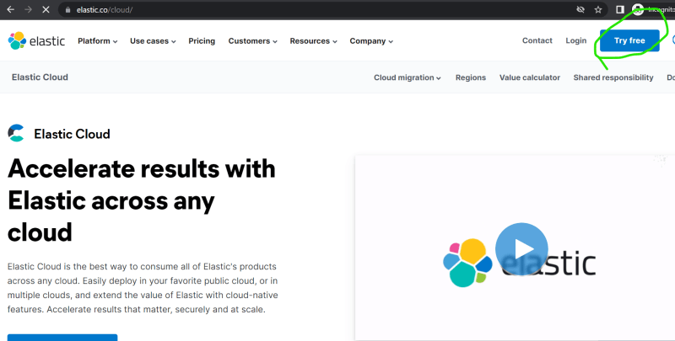  
  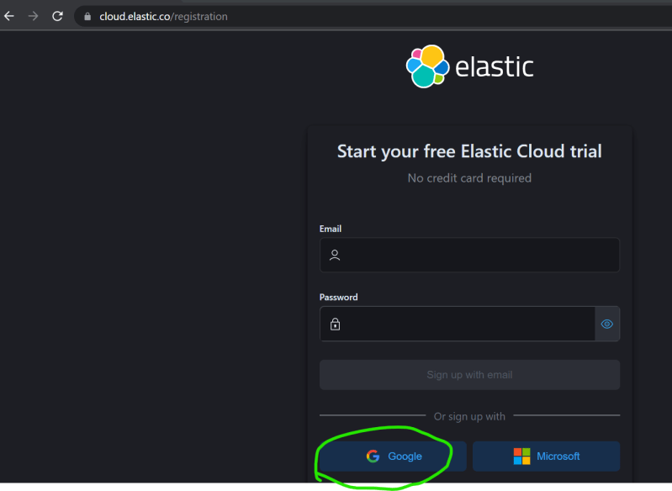  
  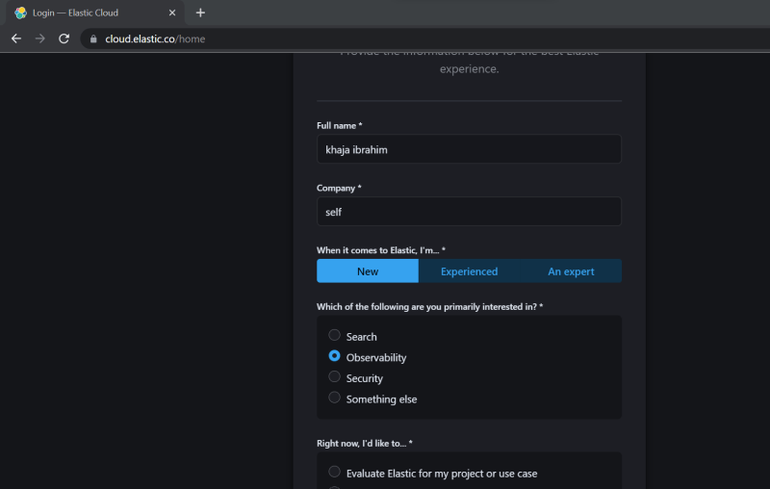  
  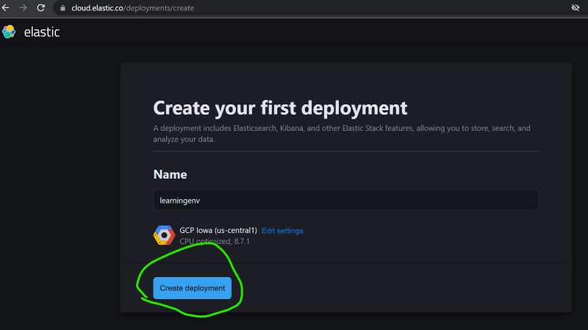  
  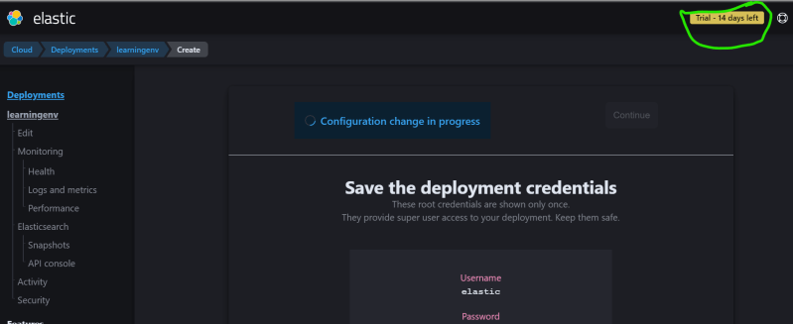  
  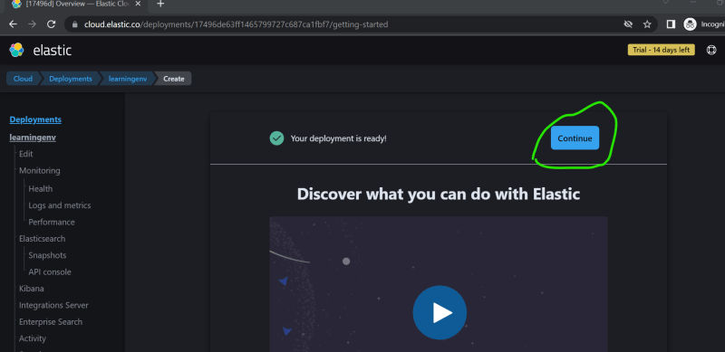  
  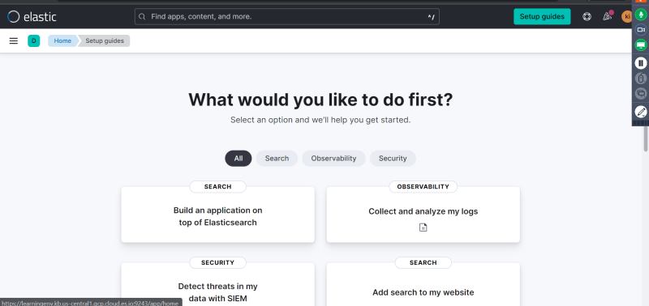
* Lets setup connectors for communications (email/teams/slack)  
  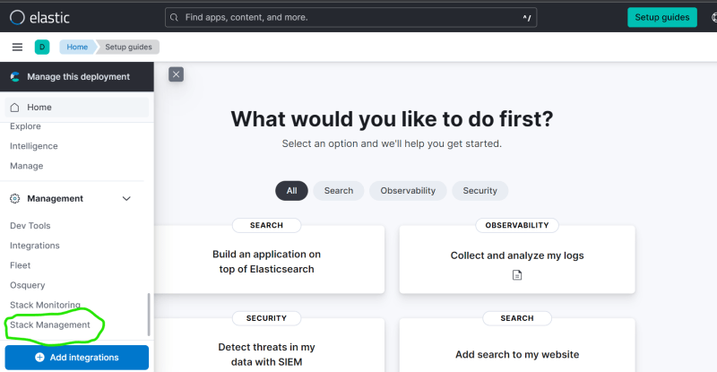  
  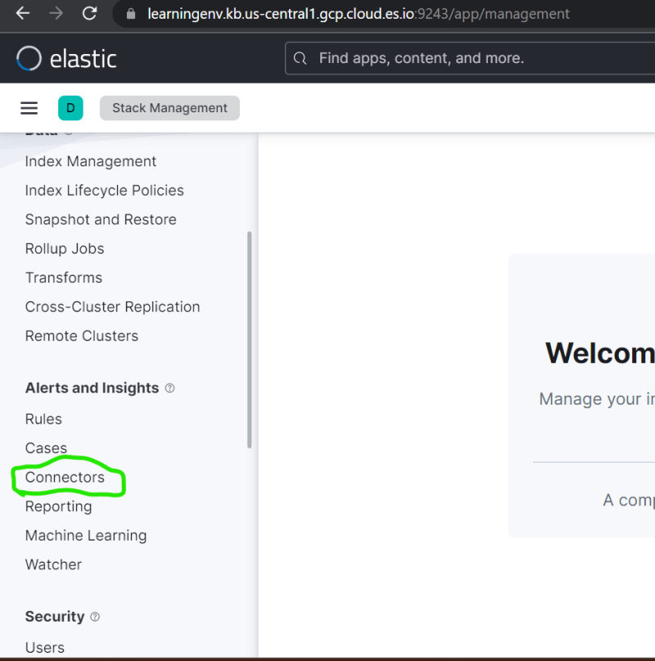  
  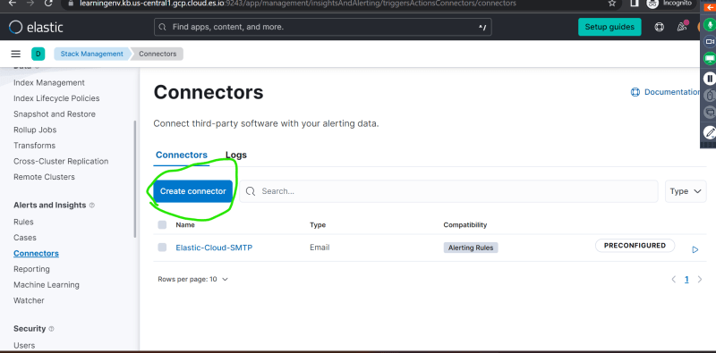  
  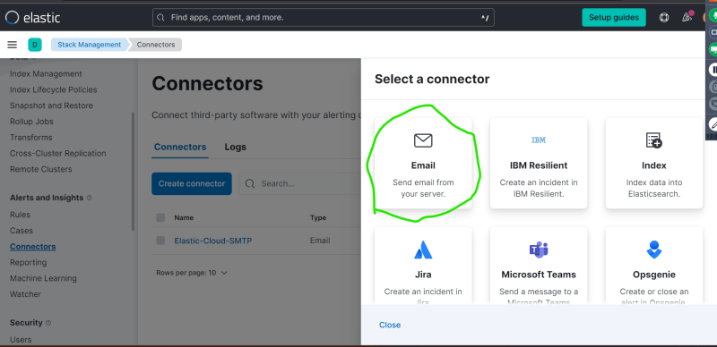
* For email create account in mailtrap and use the credentials of mail trap over here
* Enter the details of mail trap in email and run the test (refer classroom video)  
  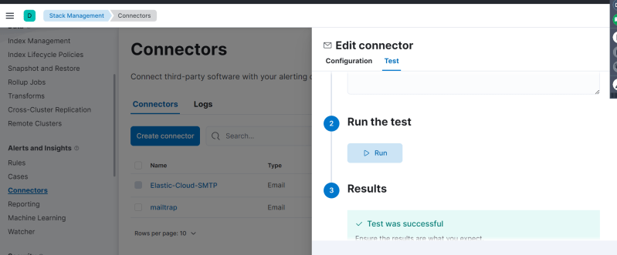  
  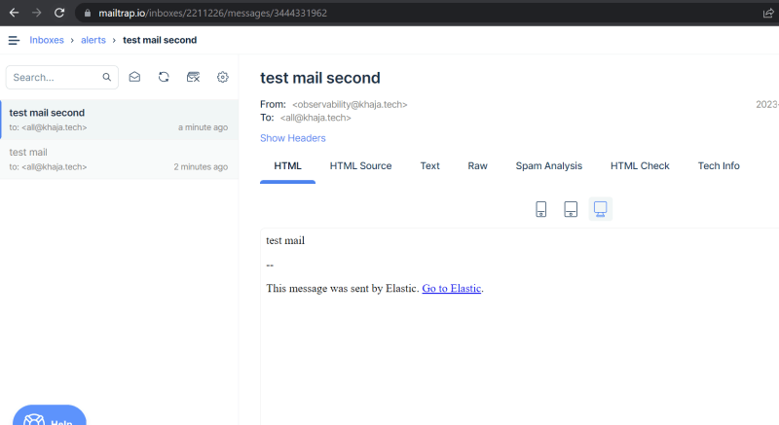

**Workflow**

* Overview  
  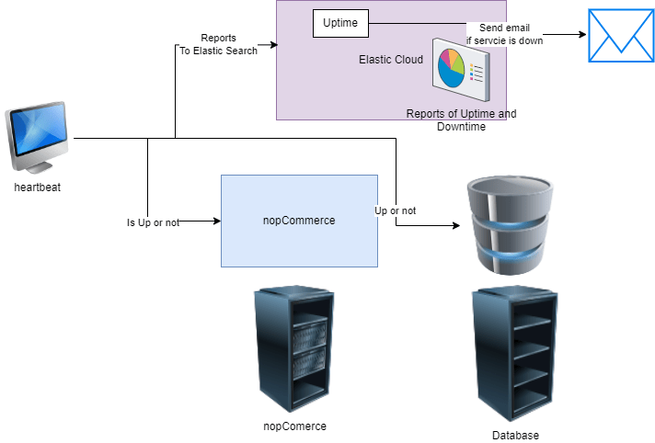
* We will have a system with heartbeat installed which checks if the application/server is up or not and reports the status to elastic cloud (elastic search)
* The uptime in observability section of elastic cloud will show the status of each service/server from which you can configure alerts based on connectors